For the dashboard below, we wanted to gain insight into publicly available SAMHA data that we populated into a Salesforce database, but at the time, Salesforce dashboard functionality was limited. So, we used Qlik to develop a far more robust dashboard to gain deep insight into modern drug experimentation across different populations in the United States.

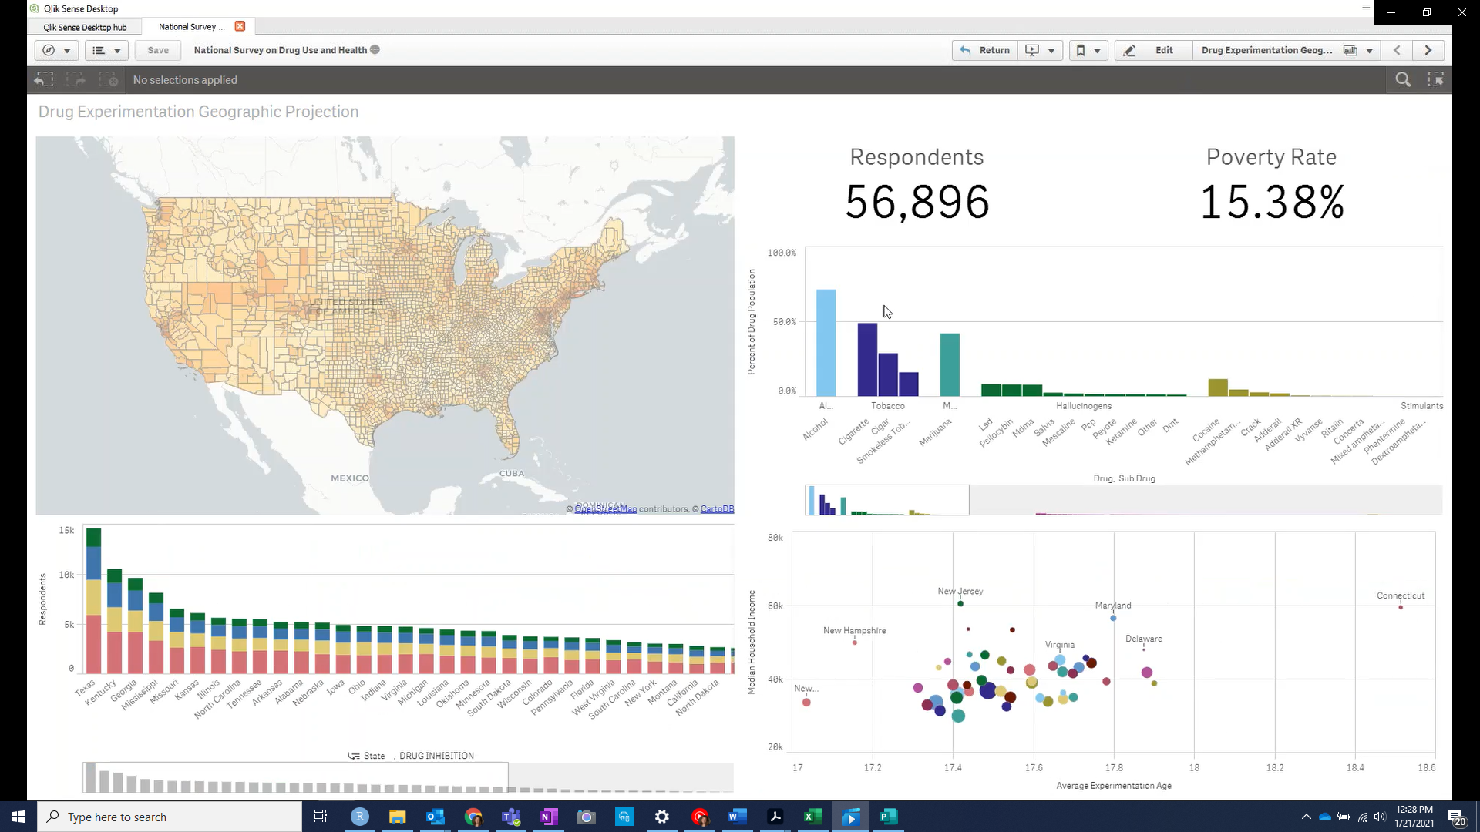Our dashboard allowed us to look at nationwide survey results at a glance:

And drill down by drug:

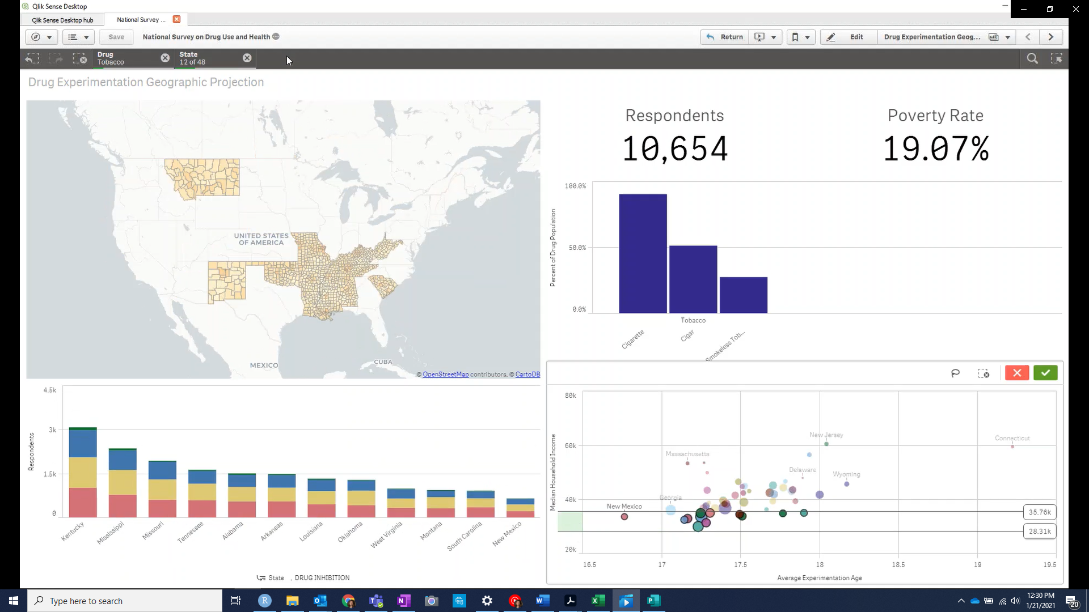

Or by state: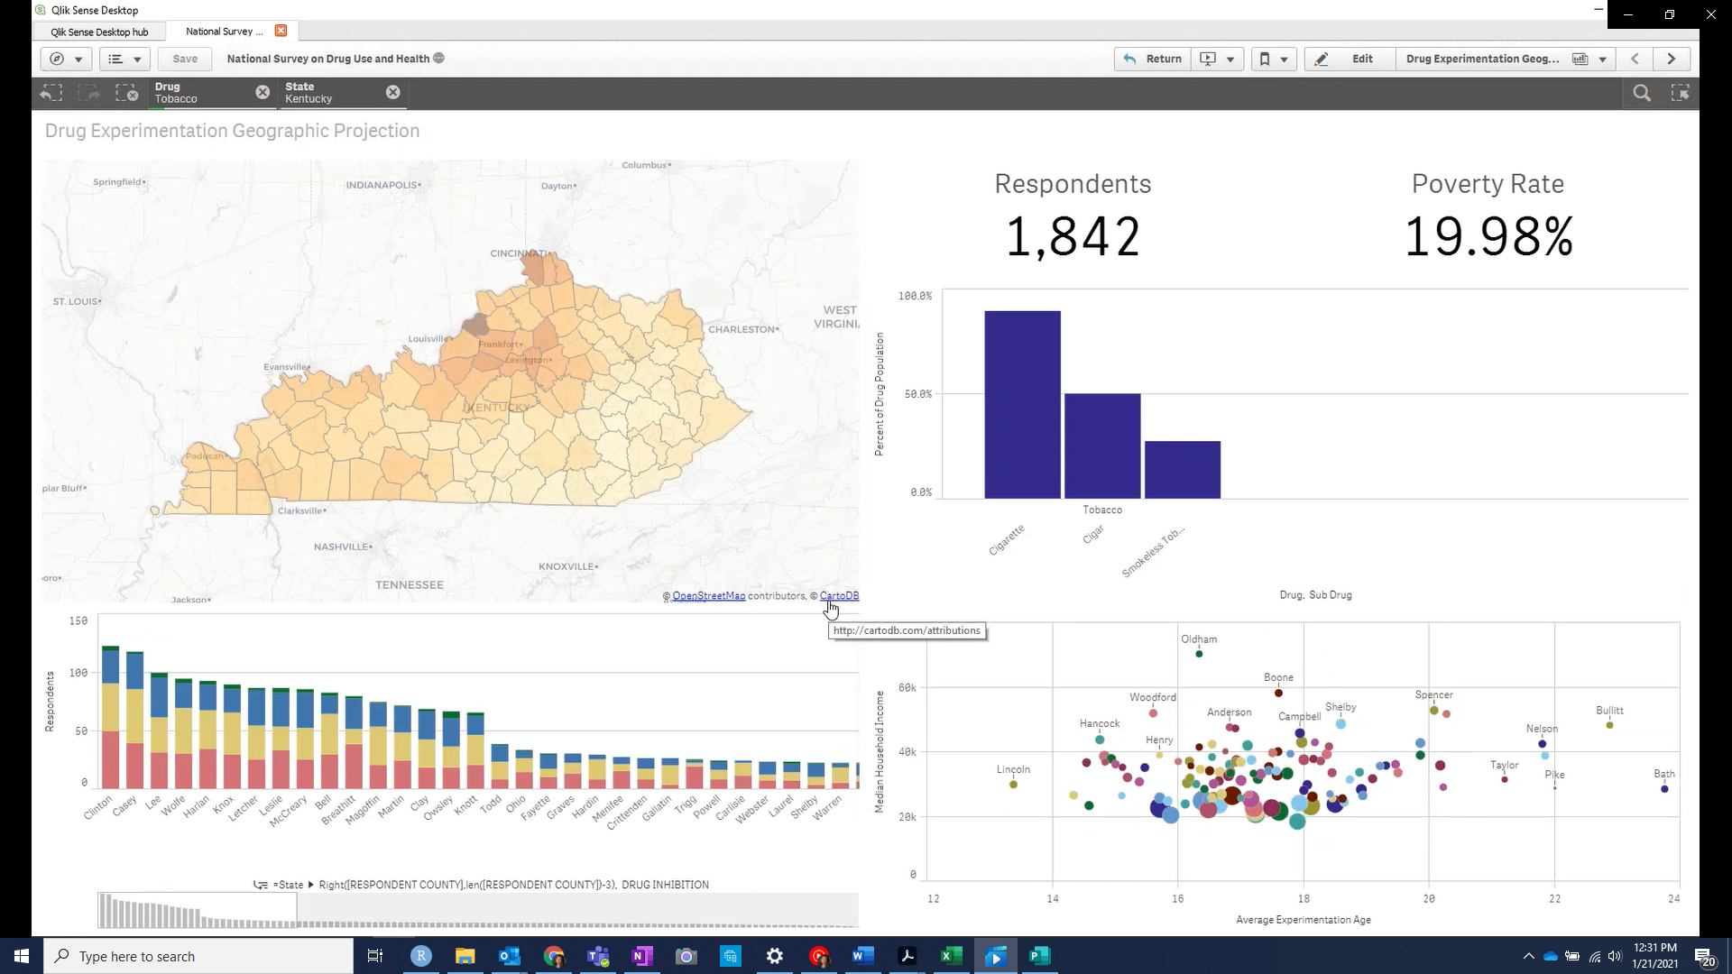

Or even a metropolitan area:

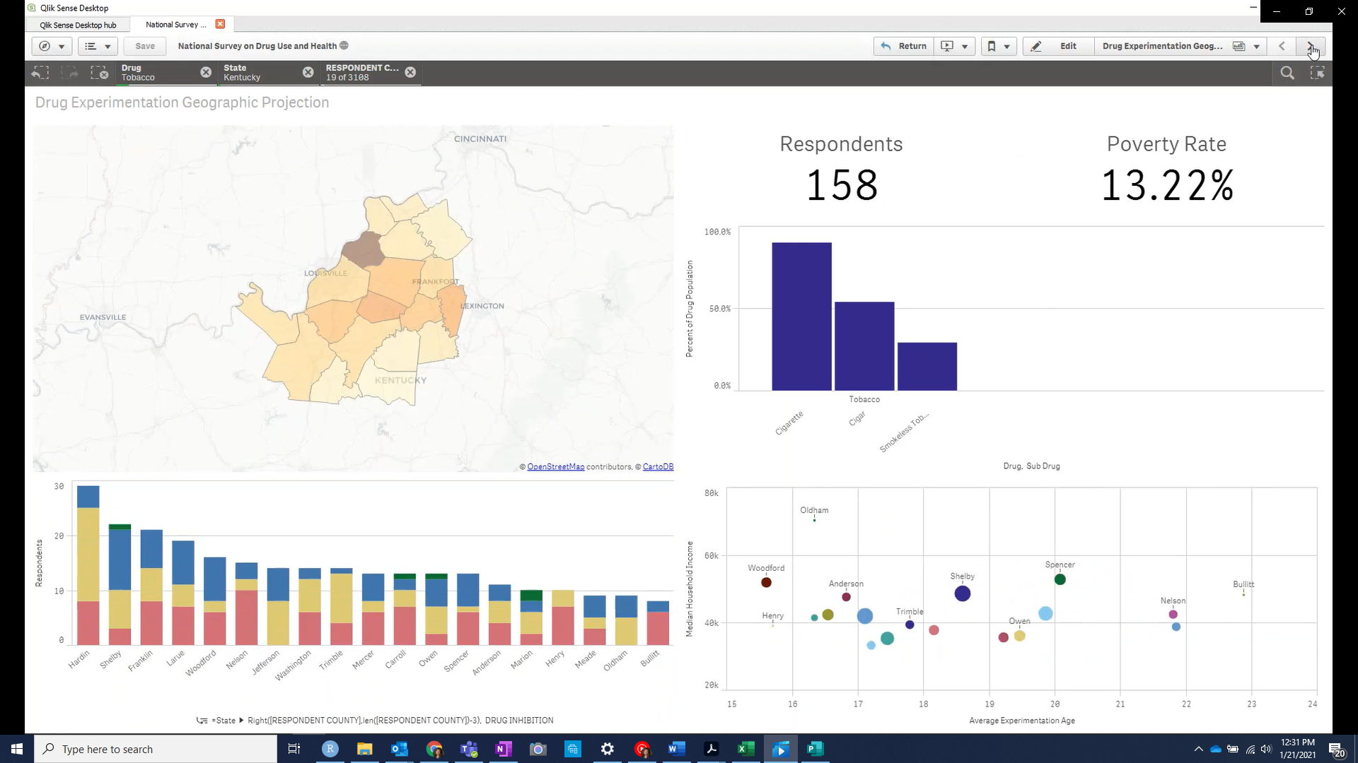

With Qlik, we were even able to look at points of overlap between respondents:

